


Anguilla Maritime Administration
& Shipping Registry

AMASR

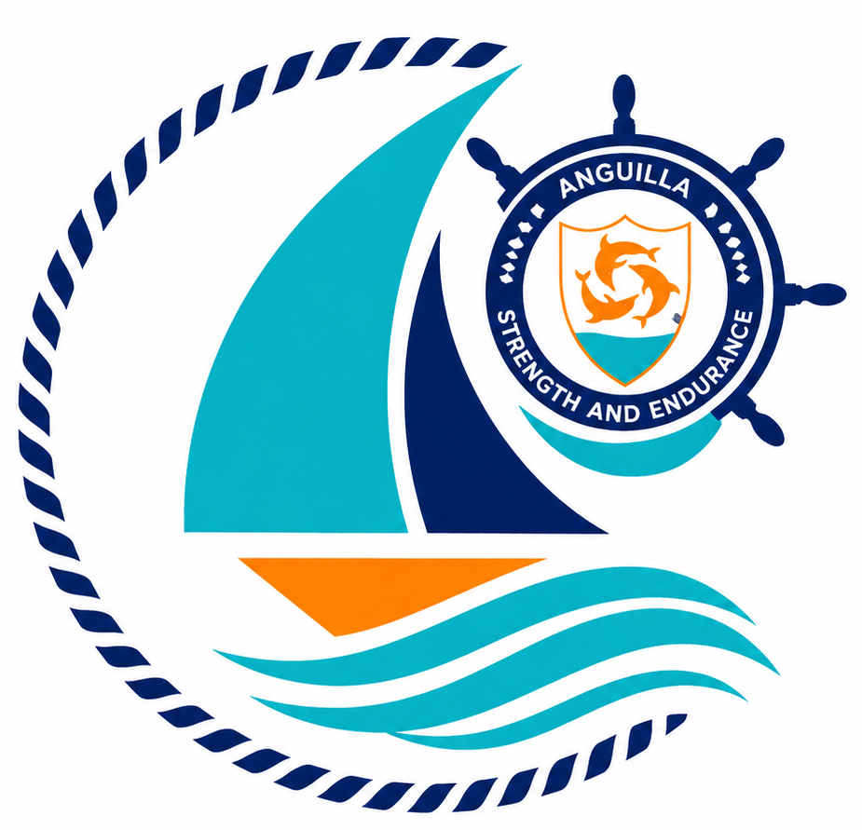

Form: | Application for Request of Amendment
No.: | 06
Rev.: | 00
Date: | 2026-06-10
To: | Recognized Organizations, Shipowners, Managers, Masters, Seafarers, Partners, Brokers, Surveyors, and the general public.

Strength and Endurance

Address: Anguilla Maritime Administration
Anguilla, Leeward Islands, Ministry of Infrastructure, Communications, Utilities and Housing, Coronation Avenue, The Valley Anguilla
Tel: +447454760022| Email: info@amasr.ai

FORM 06 - APPLICATION FOR REQUEST OF AMENDMENT

Please complete this form in its entirety, electronically or in block capitals.

1. Vessel details
Vessel Name
Vessel Official Number
IMO number (or HIN as applicable)

2. Requested amendment(s)
Tick the box for the amendment(s) being notified
1) Change of Vessel Name
Please attach form 01, new Carving and Marking note
2) Change of Ownership
Please attach form 01, 02, 03, proof of tile, valid passports, company register extract, POA as applicable
3) Change of Ownership company name and/or address
Please attach valid passports, company register extract, POA as applicable
4) Change of Resident Agent
Please attach form 02
5) Change of ISM or technical Manager
Please attach form 01, appointment of ISM manager declaration
6) Change of registration type (private or commercial yachts)
Please attach form 01 to reflect change of registration type
7) Change of Classification Society
Please attach new Certificate of Class

Please fill out the section you would like to amend.

2.1 Change of Vessel Name
New Vessel Name

2.2 Change of Ownership
New Vessel Ownership Type | Company  Individual
New Owner Name
New Owner Address
Demise Charterer Name (if applicable) | Demise Charterer Address (if applicable)
E-mail address | Telephone
Contact Person
Ultimate Beneficial Owner (UBO)

2.3 Change of Ownership Name and/or Address
New Vessel Owner Name
New Vessel Owner Address

2.4 Change of Resident Agent
New Resident Agent Name
New Resident Agent Address
E-mail address | Telephone
Contact Person

2.5 Change of ISM or Technical Manager
New Manager Type | ISM Manager  Technical Manager (Commercial Yachts <500GT)
New Manager Name
New Manager Address
E-mail address | Telephone
Contact Person
2.6 Change of Registration Type
New Registration Type | Private Yacht  Commercial Yacht

2.7 Change of Classification Society
New Classification Society Name

3. Confirmation of Current Ownership Structure
- No changes – I hereby confirm that no changes have occurred in the ownership structure since the last due diligence review. A valid UBO passport is maintained on file.

- Changes occurred – Changes have been made to the ownership structure. Kindly submit the current company register extract and valid passport copies evidencing these changes.

4. Declaration¹
I, the undersigned, declare under my own responsibility that I have not made any false or misleading statements in this form, being aware that anyone who makes false or misleading statements is punishable under the Criminal Code of the Anguilla.
I, the undersigned, further declare and confirm that all fees relating to the present registration application, as well as any current charges, have been duly paid in accordance with the applicable fee schedule of the Maritime Registry of the Anguilla.
Signatory full name in block letters | Role
Date | Signature

Note: Refer also to the guidance notes overleaf.

1 Power of attorney (or suitable corporate document) to be attached where applicable.

- For the purposes of the validity of this application, the following is specified. The form must be duly signed by the current owner of the vessel, where the owner is a natural person, or by a director of the owning company or an authorised representative duly empowered by a formal power of attorney, where the current owner is a legal person.
- Pursuant to point 3., where changes have occurred:
  - Where the current registered owner of the vessel is a company, an updated list of directors issued by a competent authority or bearing a notary’s seal shall be provided, together with a complete list of the company’s shareholders issued by a competent authority or bearing a notary’s seal, as well as copies of valid passports or identity cards of all shareholders.
  - Where the registered owner of the vessel is a natural person, a copy of a valid passport or identity card shall be provided.
- Where the application is signed by a third party, a formal power of attorney must be provided expressly specifying the delegated activity, the vessel concerned and the name of the authorised representative.
- The registered address given will be used on the Certificate of Registry. The correspondence address, if different from the registered address, will be used for the distribution of safety related information.

